Set-Var-Map Step

Objective

Initialization is the assignment of an initial value for a data object or variable. The manner in which initialization is performed depends on the programming language, as well as type, storage class, etc., of an object to be initialized.

To store the multiple variables and values in JSON format.

UI

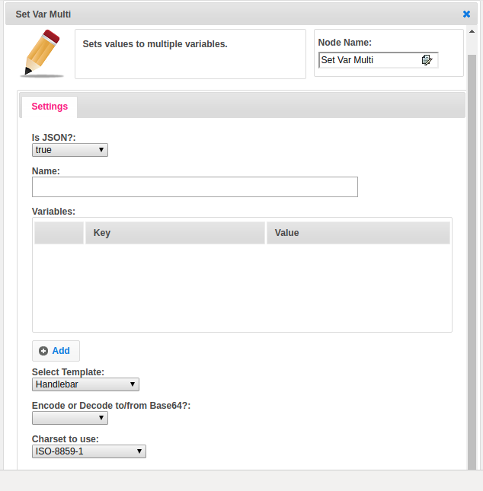

## Attributes

|  |  |
| --- | --- |
| **Attributes** | **Description** |
| **1. Is JSON?** | JSON is a boolean type to represent the given data is in JSON format or not. |
| **2. Name** | Name of the map variable name. |
| **3. Variables** | Variable is a list type variable. The variable contains the list of maps. Each map contains the key, value pair. Key holds the variable name and value contains the value of the variable. |
| **4. Select Template** | Select Template used to set the value type.  Value types are two types.  1.hb-HandleBars  2.ftl-Freemarker Template Language. |
| **5. Encode or Decode to/from Base64?:** | Base64 encoding and decoding. Base64 is a group of similar binary-to-text encoding schemes that represent binary data in an ASCII string format by translating it into a radix-64 representation. ... Base64 is commonly used in a number of applications including email via MIME, and storing complex data in XML.  Base64.Encoder presents several threadsafe instance methods for encoding byte sequences  Base64.Decoder presents several threadsafe instance methods for decoding byte sequences. |
| **6. Charset to use** | To display an HTML page correctly, a web browser must know the character set used in the page.  HTML provides different types of charsets, like few of that provided in the dropdown. Select the type based on your requirement. |

## Executor Description

In this step, get the list of variables to create the SetVarStepExecutor and SetVarStep classes object and set each variable value and name in SetVarStep class and call the execute method of SetVarStepExecutor set the output in to map. Finally, the put the all variables information in the map as value and JSON name as the key.